**1. Introduction**

* + **Project Title**: [Rhythmic Tunes: Your Melodic Companion]
  + **Team Members**: List of team members and their roles.

1. **STALIN [**Team Leader**]**
2. **SANJAY [**Member**]**
3. **SANTHOSH [**Member**]**
4. **SARAVANAN [**Member]
5. **SOLOMON KINGSTON [**Member**]**

**2. Project Overview**

* **Purpose :**  
   *Rhythmic Tunes* is a music-based web application designed to enhance the user’s listening experience by providing curated playlists, personalized recommendations, and interactive features. It aims to offer a seamless and immersive way for users to discover, play, and share music.
* **Goals:**
* Develop an intuitive and engaging music streaming interface.
* Provide personalized music recommendations based on user preferences.
* Enable users to create and share playlists with others.
* Implement a smooth and responsive UI for easy navigation.
* Ensure fast and reliable music playback with minimal buffering.
* **Features**:
* **Music Discovery** – Personalized song recommendations based on user preferences and listening history.
* **Playlist Management** – Users can create, edit, and share playlists with others.
* **Search and Filter –** Advanced search functionality to find songs, artists, and albums easily.
* **Audio Player –** A fully functional music player with play, pause, skip, and repeat features.
* **Dark & Light Mode –** Theme customization for an enhanced user experience.
* **User-Friendly Interface –** A visually appealing and responsive UI for seamless navigation.

**3. Architecture**

**Component Structure:** The frontend of *Rhythmic Tunes* is built using React.js, following a modular component-based architecture. Below is an outline of the major components and how they interact

App Component (App.js)

* + **The root component that initializes routing and global state.**
  + **Wraps the application with providers (e.g., Context API, Redux).**
  + **Manages authentication and theme settings.**

Layout Components

* + **Navbar.js –** Displays the navigation menu, search bar, and user profile options.
  + **Sidebar.js –** Provides quick access to playlists, favorite songs, and trending music.
  + **Footer.js –** Displays the currently playing song and player controls.
  + **State Management:**
* **Ideal for:** 
  + **Playback state**: This is often localized to the music player component, making Context a good fit.
  + **Smaller playlists:** If user playlists are relatively simple, Context can manage them.
  + **UI state:** Modal and loading states can be easily managed with Context**.**
* **Implementation:** 
  + **Create separate contexts for playback, playlists, and user preferences.**
  + **Use useReducer to handle complex state updates within each context.**
  + **Routing:**

The application's routing structure is designed to provide clear and logical navigation between the following key sections:

* **Home:** 
  + Displays a curated selection of songs, albums, and playlists.
  + May include featured artists and new releases.
* **Search:** 
  + Allows users to search for songs, artists, albums, and playlists.
  + Displays search results**.**
* **Library:** 
  + Displays the user's music library, including liked songs, artists, and albums.
  + Provides access to user-created playlists.

**4**.**Setup Instructions**

**PRE-REQUISITES**:-

Essential Tools & Knowledge for React Development**:**

1. **Node.js & npm (Package Manager):**  
   * Required for running JavaScript locally and managing project dependencies.
   * Download & Install: [nodejs.org/en/download/](https://nodejs.org/en/download/)
   * Installation Guides: [nodejs.org/en/download/package-manager/](https://nodejs.org/en/download/package-manager/)
2. **React.js (JavaScript Library):**
   * For building interactive and reusable UI components.
   * Create a new React project: npm create vite@latest (follow prompts).
   * Navigate to project: cd project-name, then install dependencies: npm install.
   * Run development server: npm run dev (access at http://localhost:5173).
3. **Fundamental Web Technologies:**
   * **HTML:** Structure your application's layout.
   * **CSS:** Style and design your user interface.
   * **JavaScript:** Implement client-side interactivity.
4. **Git (Version Control):**
   * Track changes, collaborate, and manage your project's history.
   * Download & Install: [git-scm.com/downloads](https://git-scm.com/downloads)
   * Use platforms like GitHub or Bitbucket for remote repositories.
5. **Code Editor/IDE:**
   * Choose a development environment for writing and managing code.
   * **Examples:** 
     + Visual Studio Code: [code.visualstudio.com/download](https://code.visualstudio.com/download)
     + Sublime Text: [sublimetext.com/download](https://www.sublimetext.com/download)
     + WebStorm: [jetbrains.com/webstorm/download](https://www.jetbrains.com/webstorm/download)
6. **Project structure:**

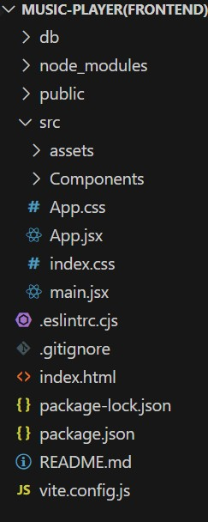

**Project Organization**: Why it Matters

* Think of your project like a well-organized toolbox. Everything has its place.
* A good structure makes your code easier to find, fix, and share with others.
* It helps you keep your project clean and manageable as it grows.

**Example:** React App Structure and the Main Component.

* In a React project, you'll have folders and files that work together.
* The src folder is where most of your code lives.
* The app folder (or similar) will contain your main component.
* app.component.css: This file contains the style rules for the main component. This controls the look of the root component.
* app.component.js (or .jsx or .tsx): This file contains the javascript code that defines the main component. This main component is what is loaded first, and it handles the overall layout of the application.
* The main component is like the "container" for your entire app. It sets up the basic layout and decides which "pages" (other components) to show**.**

**Milestone1:  
 Project Setup and Configuration:**

**1. Install required tools and software:**

* Installation of required tools:

**1. Open the project folder to install necessary tools In this project, we use:**

* + **React Js**

**o React Router Dom**

**o React Icons o Bootstrap/tailwind css**

* + **Axios**

* **For further reference, use the following resources**

**o** [**https://react.dev/learn/installation**](https://react.dev/learn/installation)

**o** [**https://react-bootstrap-v4.netlify.app/getting-started/introduction/**](https://react-bootstrap-v4.netlify.app/getting-started/introduction/)

**o**[**https://axios-http.com/docs/intro**](https://axios-http.com/docs/intro)

**o** [**https://reactrouter.com/en/main/start/tutorial**](https://reactrouter.com/en/main/start/tutorial)

**Milestone 2: Project Development:**

**1. Setup React Application:**

* **Create React application.**
* **Configure Routing.**
* **Install required libraries.**

**Setting Up Routes:-**

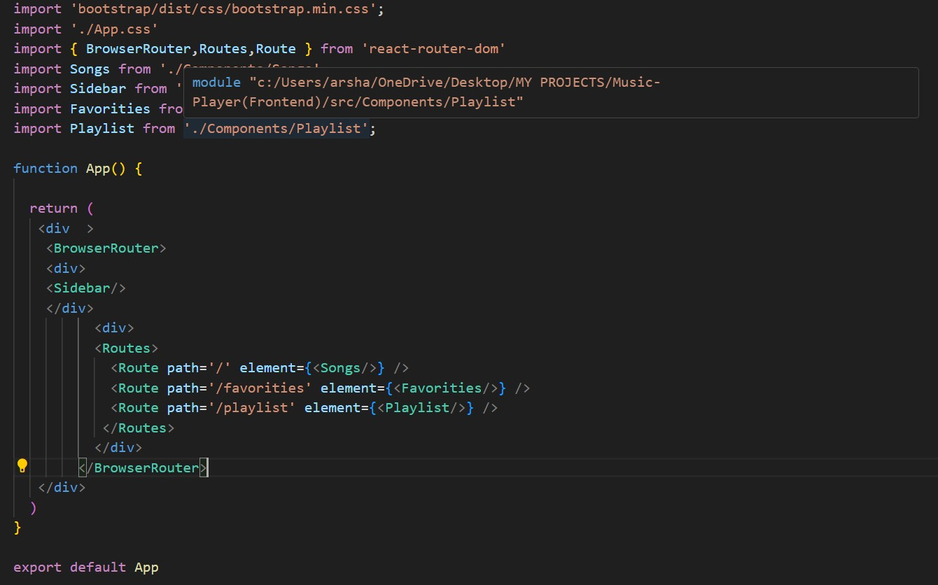

**Code Description:-**

**The App Component:** Your Project's Main Hub

* **Styling:** 
  + Uses Bootstrap's CSS for basic styling.
  + Adds custom styles from App.css for further customization.
* **Routing (Navigation):** 
  + Uses react-router-dom to manage different "pages" within the app.
  + BrowserRouter sets up the routing system.
  + Routes and Route define which components show up at which URLs.
* **Structure:** 
  + The App component is the main container for the entire app.
  + It includes a Sidebar component (for navigation or other content).
  + It also includes Routes to show different content based on the URL.
* **Pages (Routes):** 
  + / shows the Songs component.
  + /favorities shows the Favorities component.
  + /playlist shows the Playlist component.
* **Export:** 
  + The App component is exported, so other parts of the app can use it.

**Fetching Songs:-**

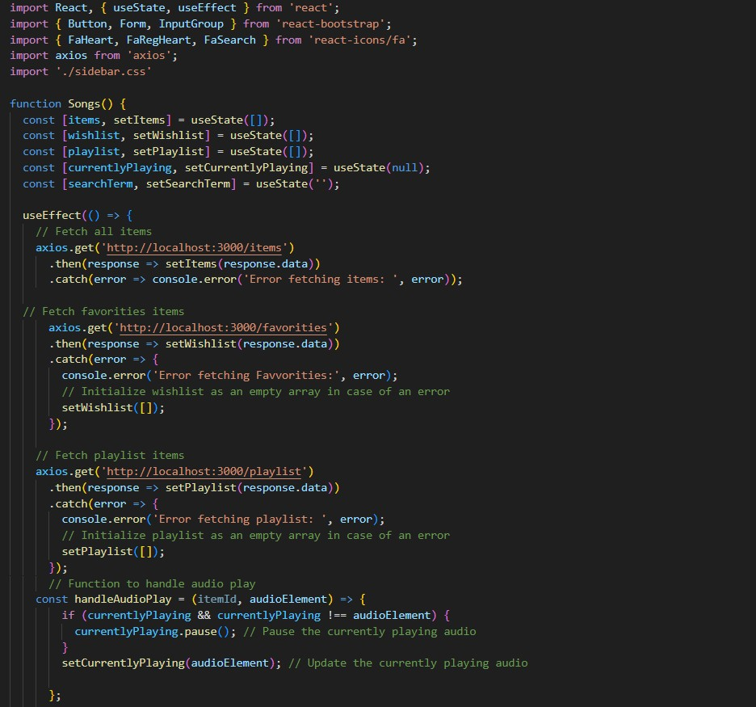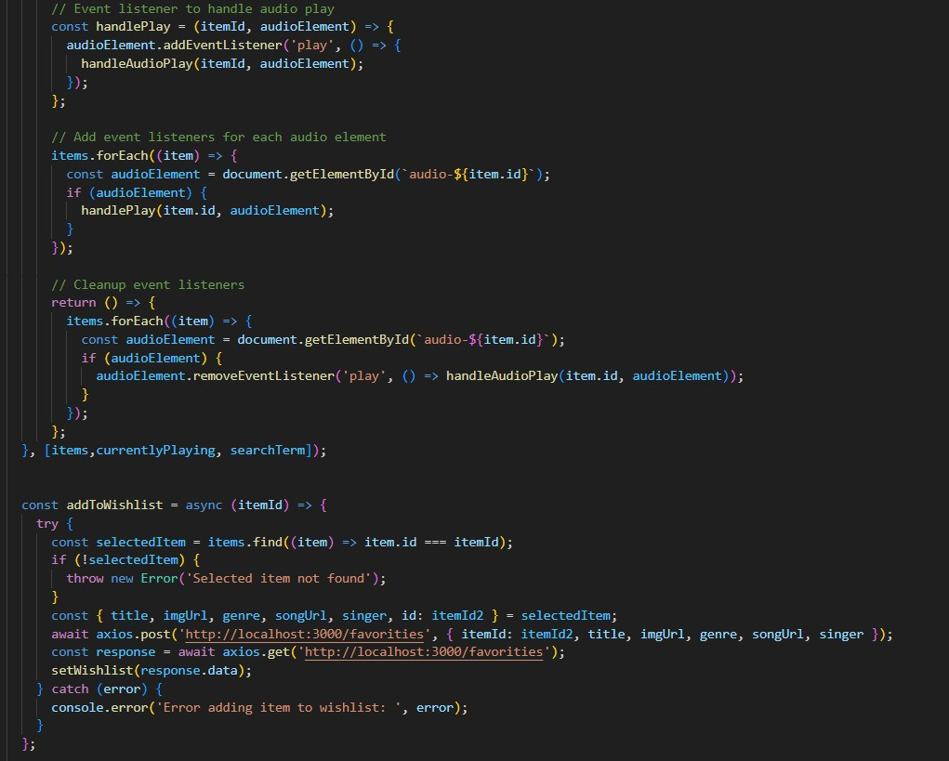

**Code Description:-**

**Use State:**

**items: Holds an array of all items fetched from http://localhost:3000/items.**

**wishlist:** Stores items marked as favorites fetched from http://localhost:3000/favorities.

**playlist:** Stores items added to the playlist fetched from http://localhost:3000/playlist**.**

**ocurrentlyPlaying:** Keeps track of the currently playing audio element. o searchTerm: Stores the current search term entered by the user.

* **Data Fetching:** 
  + **Uses useEffect to fetch data:**

**▪** Fetches all items (items) from http://localhost:3000/items.

▪ Fetches favorite items (wishlist) from

**http://localhost:3000/favorities.**

**▪** Fetches playlist items (playlist) from

http://localhost:3000/playlist. o Sets state variables (items, wishlist, playlist) based on the fetched data.

* **Audio Playback Management:** 
  + **Sets up audio play event listeners and cleanup for each item:**

**▪ handleAudioPlay**: Manages audio playback by pausing the currently playing audio when a new one starts.

**▪ handlePlay:** Adds event listeners to each audio element to trigger handleAudioPlay.

* + Ensures that only one audio element plays at a time by pausing others when a new one starts playing.
* **addToWishlist(itemId):** 
  + Adds an item to the wishlist (favorities) by making a POST request to http://localhost:3000/favorities. o Updates the wishlist state after adding an item.
* **removeFromWishlist(itemId):** 
  + Removes an item from the wishlist (favorities) by making a DELETE request to http://localhost:3000/favorities/{itemId}. o Updates the wishlist state after removing an item**.**
* **isItemInWishlist(itemId):** 
  + Checks if an item exists in the wishlist (favorities) based on its itemId.
* **addToPlaylist(itemId):**

**o** Adds an item to the playlist (playlist) by making a POST request to http://localhost:3000/playlist. o Updates the playlist state after adding an item.

* **removeFromPlaylist(itemId):**

o Removes an item from the playlist (playlist) by making a DELETE request to http://localhost:3000/playlist/{itemId}.

o Updates the playlist state after removing an item.

* **isItemInPlaylist(itemId):**

**o** Checks if an item exists in the playlist (playlist) based on its itemId.

* **filteredItems:** 
  + - Filters items based on the searchTerm.
    - Matches title, singer, or genre with the lowercase version of searchTerm.
* **JSX:**
* Search: Search bar for finding items.
* List: Displays matching items.
* Actions: Add/remove from favorites/playlists**.**
* **Audio: Play/pause audio for each item.Error Handling:**

o Catches and logs errors during data fetching (axios.get).

o Handles errors when adding/removing items from wishlist and playlist.

**Frontend Code For Displaying Songs:-   
  
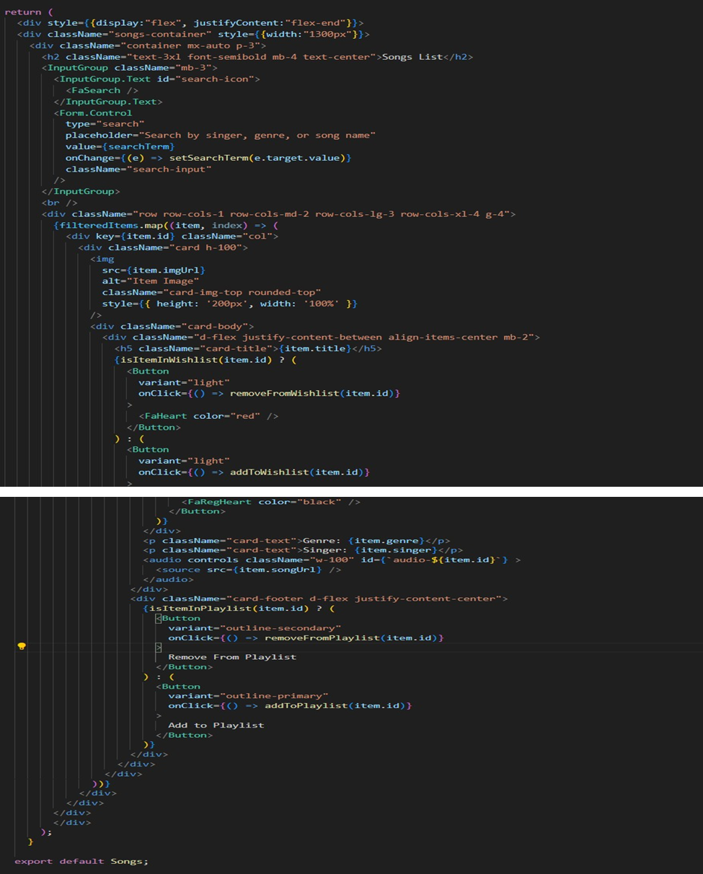**

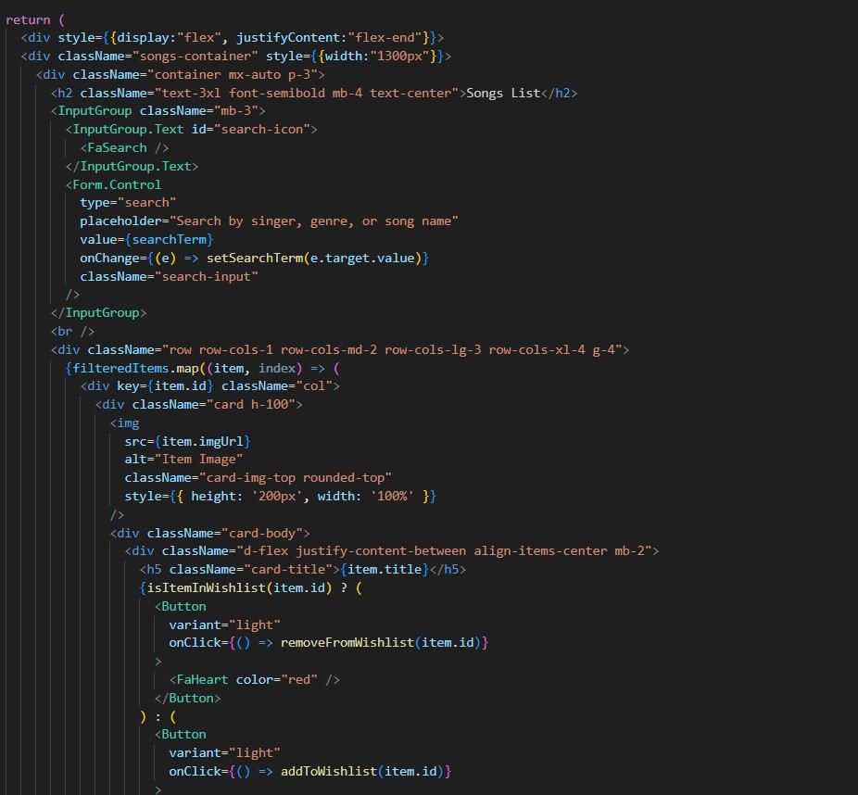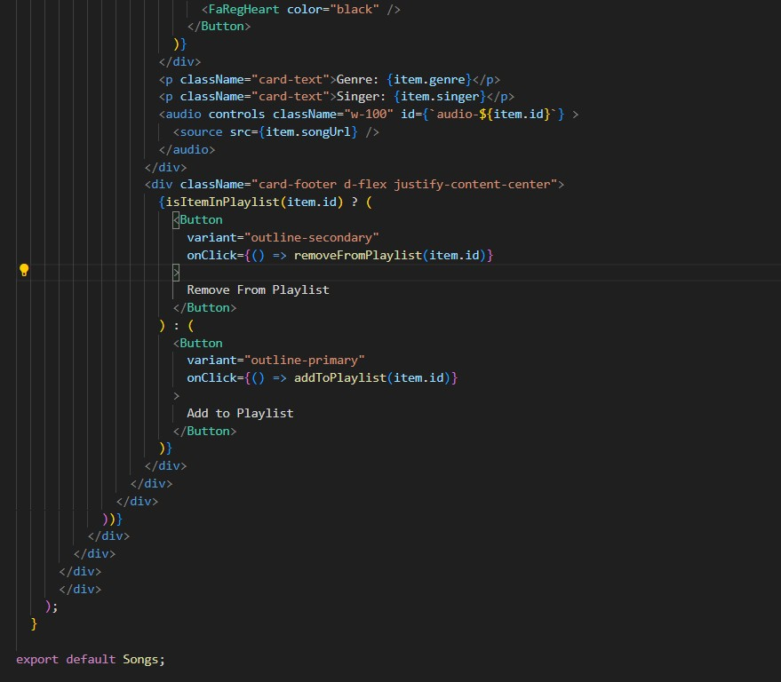

**Layout:**

* Right-aligned container with a fixed-width section for song display.
* Responsive grid layout using Bootstrap cards.

**Header & Search:**

* "Songs List" heading.
* Search bar (singer, genre, song name) using React Bootstrap's InputGroup.

**Song Cards:**

* Displays song information (image, title, genre, singer) in cards.
* Includes an audio player for each song.

**Wishlist & Playlist:**

* Heart icon button to add/remove songs from the wishlist.
* "Add/Remove from Playlist" buttons**.**

**Functionality:**

* Handles adding/removing songs from wishlist and playlist.
* Uses Bootstrap and custom styles for card and element appearance.

**Project Execution:**

* To run your React music application, you'll need to start two servers. First, open your terminal and use npm start (or npm run dev for Vite) to launch the React development server. This will make your application accessible in your web browser.
* Next, open a separate terminal window and run json-server --watch ./db/db.json. This command starts a JSON server, which provides the data your music appneeds from **t**he db.json file. This ensures your app has access to the song information and other necessary data.
* Finally, open your web browser and navigate to the address provided by the React development server (usually http://localhost:3000 or http://localhost:5173). You should now see your "Rythimic Tunes" application running, and you can refer to the provided screenshots to verify it's working correctly.

**Hero components**

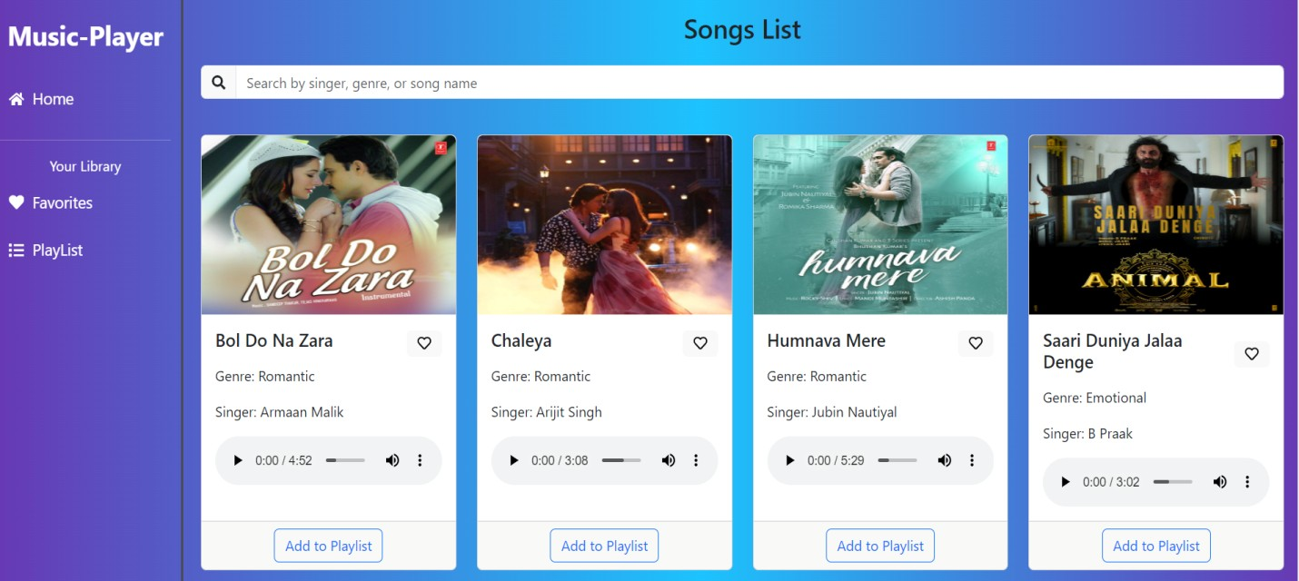

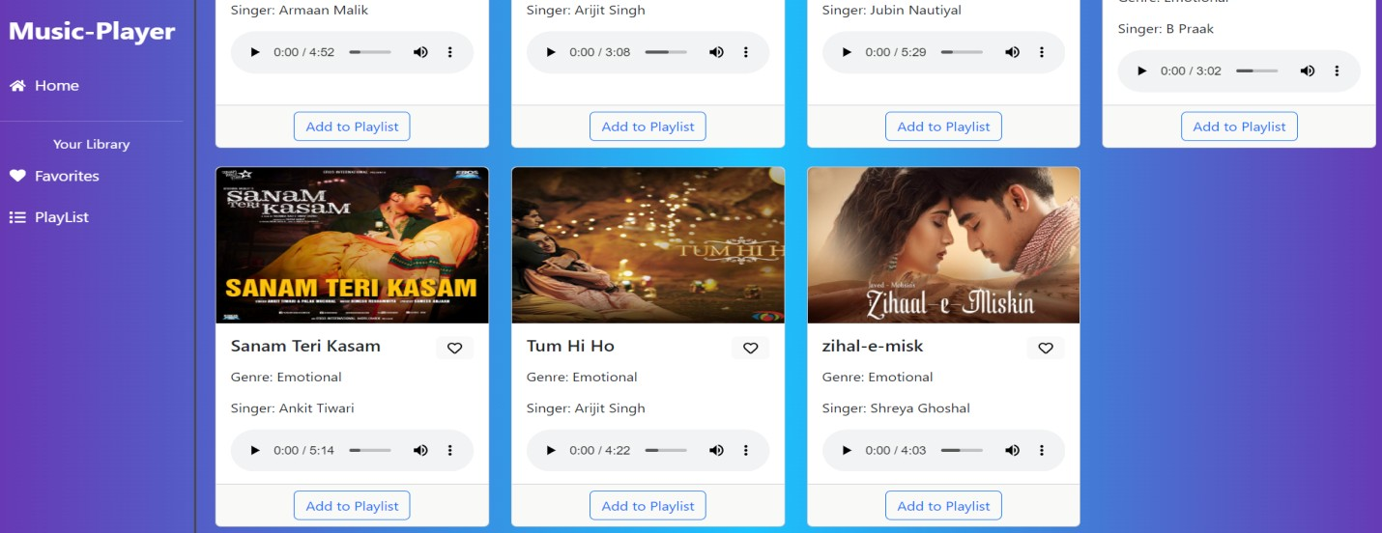

**Playlist**

**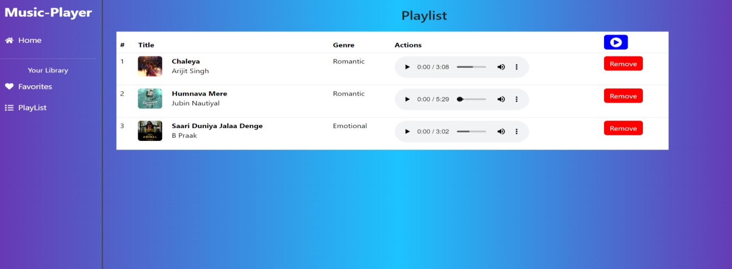   
  
  
  
  
  
Favorites**

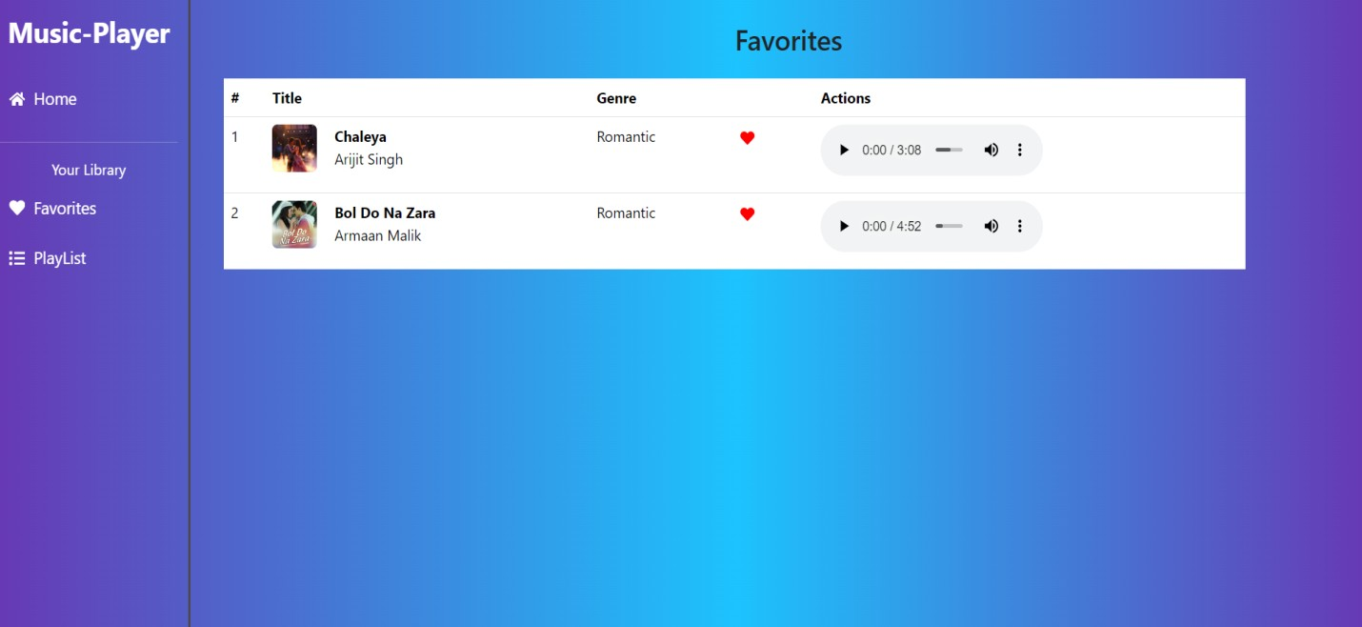

**Future Enhancements**

**. Audio Playback & User Experience:**

**Gapless Playback**: Implement seamless transitions between tracks for a smoother listening experience.

**Crossfade:** Allow users to enable crossfade between songs**.**

**Equalizer & Audio** Effects: Integrate an equalizer and other audio effects for personalized sound customization.

**Lyrics Integration:** Display synchronized lyrics during playback.

**Offline Playback**: Enable users to download songs and playlists for offline listening.

**Podcast Support**: Expand the app to include podcast playback**.**

**Spatial Audio Support:** integrate support for spatial audio technologies**.**

**Voice Control**: Integrate voice commands for playback control and navigation.

**Sleep Timer:** Implement a sleep timer feature to automatically stop playback after a specified duration.

**Visualizers:** Add visualizers that react to the music being played.

**2. Social & Community Features:**

**Social Sharing:** Allow users to share their favorite songs, playlists, and artists on social media.

**Collaborative** Playlists: Enable users to create and edit playlists together.

**Artist Profiles**: Enhance artist profiles with more detailed information, including biographies, discographies, and social media links.

**User Profiles**: Allow users to customize their profiles and follow other users.

**Comment Sections:** add comment sections to songs, albums, and playlists.

**Live Listening Sessions:** allow users to listen to music together in real time.

**3. Music Discovery & Personalization:**

**Advanced Recommendations:** Improve music recommendations based on listening history, preferences, and social data.

**Mood-Based Playlists:** Generate playlists based on user-selected moods or activities.

**Genre Exploration:** Enhance genre browsing and discovery.

**"Discover Weekly" Style Playlists:** Generate personalized weekly playlists based on user listening habits.

**Integration with Music Recognition Services:** Allow users to identify songs playing in their environment.

**4. Library & Playlist Management:**

**Smart Playlists:** Create playlists based on user-defined criteria (e.g., most played, recently added).

**Playlist Folders:** Allow users to organize playlists into folders.

**Advanced Search Filters**: Implement more granular search filters (e.g., by genre, year, album).

**Cloud Library Sync**: Synchronize user libraries and playlists across multiple devices.

**Import/Export Playlists:** allow users to import and export playlists in common formats.

**5. User Interface & Accessibility:**

**Customizable Themes:** Allow users to customize the app's appearance.

**Accessibility Improvements:** Enhance accessibility for users with disabilities (e.g.,   
  
screen reader support, keyboard navigation).

**Responsive Design:** Ensure the app is optimized for different screen sizes and devices.

**Dark Mode:** ensure a high quality dark mode is available.

**Improved Navigation:** continue to improve the navigation flow.

**6. Platform & Integration:**

**Desktop Application:** Develop a desktop version of the app.

**Smartwatch Integration:** Integrate with smartwatches for playback control and offline listening.

**Smart Speaker Integration:** Integrate with smart speakers for voice control and   
playback.

**Car Integration:** Integrate with in-car entertainment systems.

**API Development:** create a public API for developers.

**7. Data & Analytics:**

**Listening Statistics:** Provide users with detailed listening statistics (e.g., most played songs, artists, genres).

**Usage Analytics:** Collect usage data to improve the app's features and performance.

**Artist Analytics:** provide artists with data regarding their listeners**.**

**8. Monetization (if applicable):**

**Subscription Tiers:** Offer different subscription tiers with varying features and benefits.

**In-App Purchases**: Allow users to purchase additional features or content.

**Artist Merch Integration:** allow users to purchase artist merchandise.

THANKYOU